start | 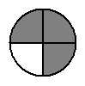 | $$\frac{3}{4}$$ | 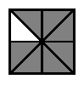
$$\frac{7}{8}$$ | 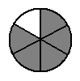 | $$\frac{5}{6}$$ | 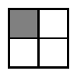
$$\frac{1}{4}$$ | 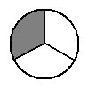 | $$\frac{1}{3}$$ | 
$$\frac{2}{3}$$ | 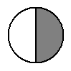 | $$\frac{1}{2}$$ | 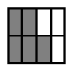
$$\frac{5}{8}$$ | 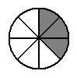 | $$\frac{3}{8}$$ | 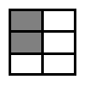
$$\frac{2}{6}$$ |  | $$\frac{3}{5}$$ | einde

